IT3037c
Lab#09: Amazon ElastiCache

In this lab, you will study Amazon ElastiCache. You will use the AWS CLI to manage the ElastiCache.

Tools and Materials
- One Ubuntu VM on the vSphere servers
- Amazon AWS security files
- AWS CLI

Note: You need to replace words in italics with your information. Be sure to show your output.
Questions will be in red.
Part 1: Create an ElastiCache cluster
    - Log into your Ubuntu VM
    - Navigate to the VPC tab in the AWS Console and find your subnet ID for your us-east-1a public VPC
What is your VPC ID, what is your Subnet ID for us-east-1a public subnet?

Vpc-0202cda9d76509845
Subnet-048109d99999c8dae

Following this we must create a subnet group with the following command:

aws elasticache create-cache-subnet-group \
--cache-subnet-group-name mysubnetgroup \
--cache-subnet-group-description "Testing" \
--subnet-ids yoursubnetID

aws elasticache create-cache-subnet-group \
--cache-subnet-group-name mysubnetgroup \
--cache-subnet-group-description "Testing" \
--subnet-ids subnet-048109d99999c8dae

What is the output?
{
"CacheSubnetGroup": {
"CacheSubnetGroupName": "mysubnetgroup",
"CacheSubnetGroupDescription": "Testing",
"VpcId": "vpc-0202cda9d76509845",
"Subnets": [
{
"SubnetIdentifier": "subnet-048109d99999c8dae",
"SubnetAvailabilityZone": {
"Name": "us-east-1a"
},
"SupportedNetworkTypes": [
"ipv4"
]
}
],
"ARN": "arn:aws:elasticache:us-east-1:078646182234:subnetgroup:mysubnetgroup",
"SupportedNetworkTypes": [
"ipv4"
]
}
}

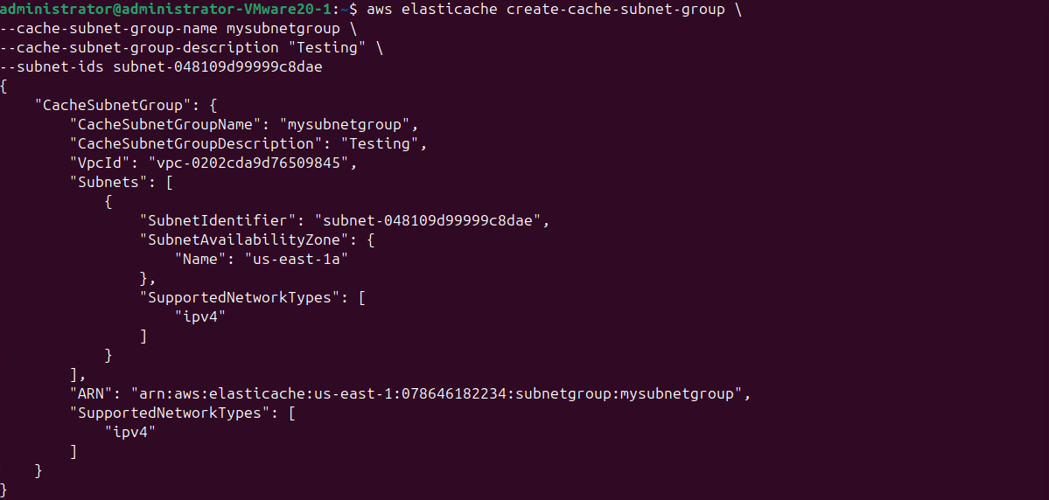

- Create a cache cluster with a cluster node running the Memcached cache engine via the following command:

aws elasticache create-cache-cluster --cache-cluster-id your_username-cc --cache-node-type cache.t3.micro --engine memcached --num-cache-nodes 1 --security-group-ids your_sec_grp_id --cache-subnet-group-name mysubnetgroup

aws elasticache create-cache-cluster --cache-cluster-id hazlettsammy-cc --cache-node-type cache.t3.micro --engine memcached --num-cache-nodes 1 --security-group-ids sg-0e8b8b55ca4766f03 --cache-subnet-group-name mysubnetgroup

What is the output?
Note that you use the name not the id

{
"CacheCluster": {
"CacheClusterId": "hazlettsammy-cc",
"ClientDownloadLandingPage": "https://console.aws.amazon.com/elasticache/home#client-download:",
"CacheNodeType": "cache.t3.micro",
"Engine": "memcached",
"EngineVersion": "1.6.22",
"CacheClusterStatus": "creating",
"NumCacheNodes": 1,
"PreferredMaintenanceWindow": "sun:03:30-sun:04:30",
"PendingModifiedValues": {},
"CacheSecurityGroups": [],
"CacheParameterGroup": {
"CacheParameterGroupName": "default.memcached1.6",
"ParameterApplyStatus": "in-sync",
"CacheNodeIdsToReboot": []
},
"CacheSubnetGroupName": "mysubnetgroup",
"AutoMinorVersionUpgrade": true,
"SecurityGroups": [
{
"SecurityGroupId": "sg-0e8b8b55ca4766f03",
"Status": "active"
}
],
"TransitEncryptionEnabled": false,
"AtRestEncryptionEnabled": false,
"ARN": "arn:aws:elasticache:us-east-1:078646182234:cluster:hazlettsammy-cc",
"ReplicationGroupLogDeliveryEnabled": false,
"LogDeliveryConfigurations": [],
"NetworkType": "ipv4",
"IpDiscovery": "ipv4"
}
}
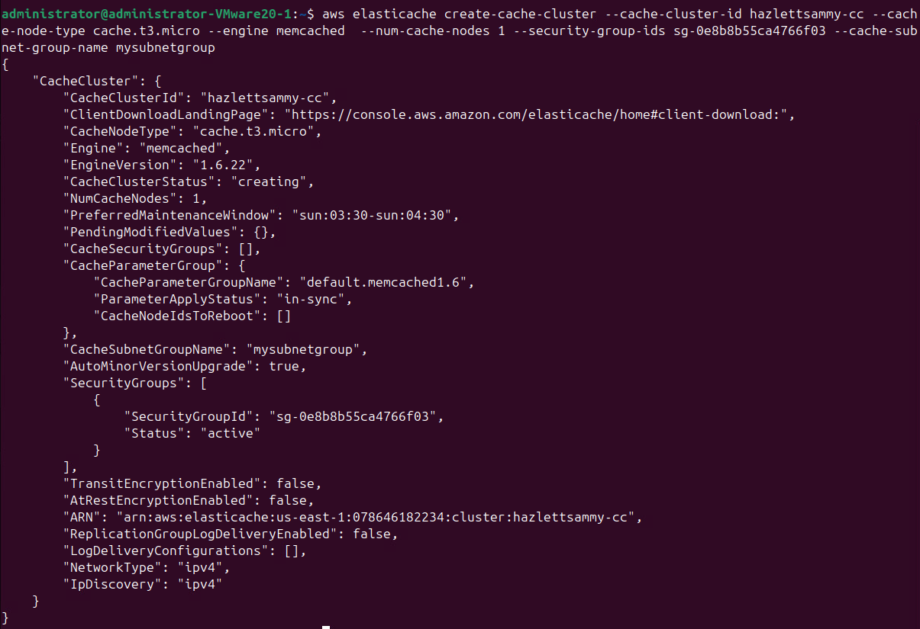

- Wait for 2 minutes and then check the cluster information with the following command:
aws elasticache describe-cache-clusters --cache-cluster-id your_username-cc
aws elasticache describe-cache-clusters --cache-cluster-id hazlettsammy-cc

What is the output? What is the URL address of your elasticache cluster endpoint? What is the port number of your elasticache cluster endpoint?
{
"CacheClusters": [
{
"CacheClusterId": "hazlettsammy-cc",
"ConfigurationEndpoint": {
"Address": "hazlettsammy-cc.mb3sdu.cfg.use1.cache.amazonaws.com",
"Port": 11211
},
"ClientDownloadLandingPage": "https://console.aws.amazon.com/elasticache/home#client-download:",
"CacheNodeType": "cache.t3.micro",
"Engine": "memcached",
"EngineVersion": "1.6.22",
"CacheClusterStatus": "creating",
"NumCacheNodes": 1,
"PreferredAvailabilityZone": "us-east-1a",
"PreferredMaintenanceWindow": "sun:03:30-sun:04:30",
"PendingModifiedValues": {},
"CacheSecurityGroups": [],
"CacheParameterGroup": {
"CacheParameterGroupName": "default.memcached1.6",
"ParameterApplyStatus": "in-sync",
"CacheNodeIdsToReboot": []
},
"CacheSubnetGroupName": "mysubnetgroup",
"AutoMinorVersionUpgrade": true,
"SecurityGroups": [
{
"SecurityGroupId": "sg-0e8b8b55ca4766f03",
"Status": "active"
}
],
"AuthTokenEnabled": false,
"TransitEncryptionEnabled": false,
"AtRestEncryptionEnabled": false,
"ARN": "arn:aws:elasticache:us-east-1:078646182234:cluster:hazlettsammy-cc",
"ReplicationGroupLogDeliveryEnabled": false,
"LogDeliveryConfigurations": [],
"NetworkType": "ipv4",
"IpDiscovery": "ipv4"
}
]
}

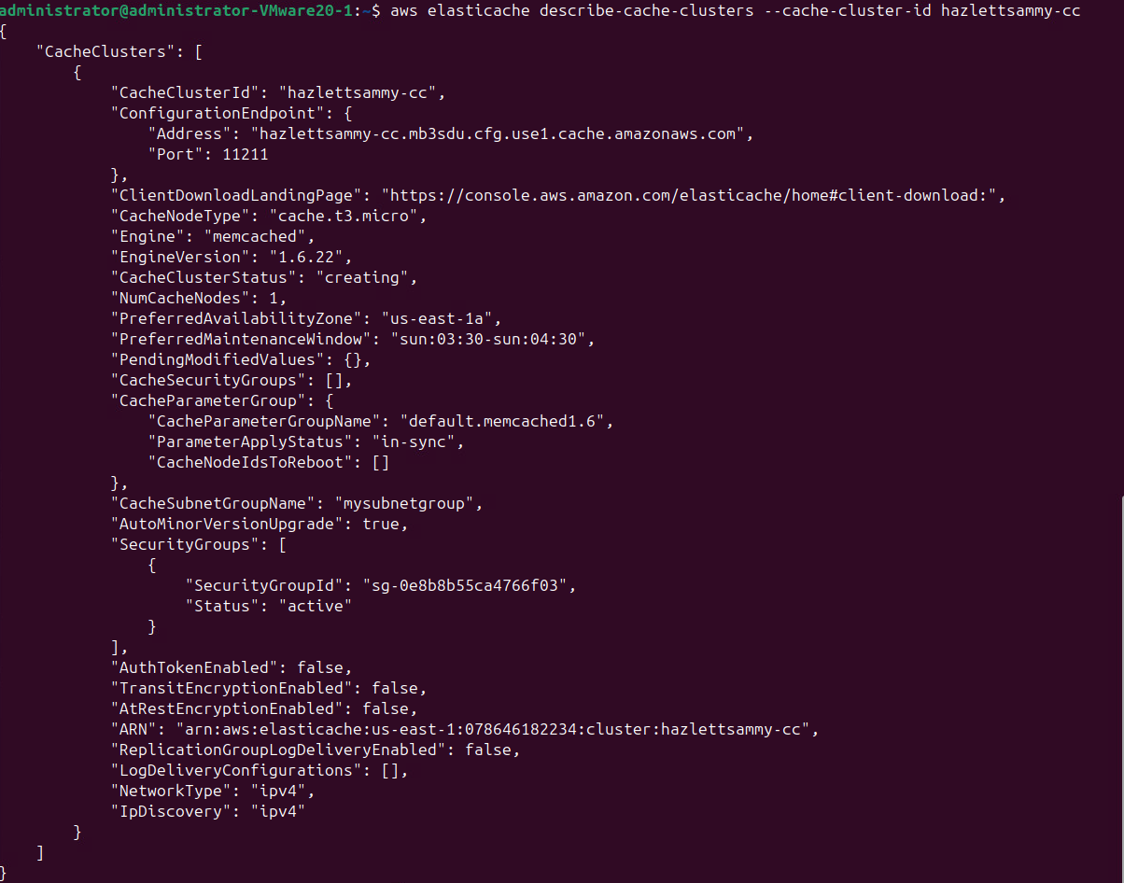
hazlettsammy-cc.mb3sdu.cfg.use1.cache.amazonaws.com
Port: 11211

If you don’t see the ConfigurationEndpoint block in the output, please wait for a while and then run the command again.

- Allows network ingress to your cache security group via the following command:

aws ec2 authorize-security-group-ingress \
--group-id yoursecuritygroupID \
--protocol tcp \
--port 11211 \
--cidr 10.0.0.0/0

aws ec2 authorize-security-group-ingress \
--group-id sg-0e8b8b55ca4766f03 \
--protocol tcp \
--port 11211 \
--cidr 10.0.0.0/0

What is the output?

{
"Return": true,
"SecurityGroupRules": [
{
"SecurityGroupRuleId": "sgr-0bd66bbae1e3e37f7",
"GroupId": "sg-0e8b8b55ca4766f03",
"GroupOwnerId": "078646182234",
"IsEgress": false,
"IpProtocol": "tcp",
"FromPort": 11211,
"ToPort": 11211,
"CidrIpv4": "0.0.0.0/0",
"SecurityGroupRuleArn": "arn:aws:ec2:us-east-1:078646182234:security-group-rule/sgr-0bd66bbae1e3e37f7"
}
]
}

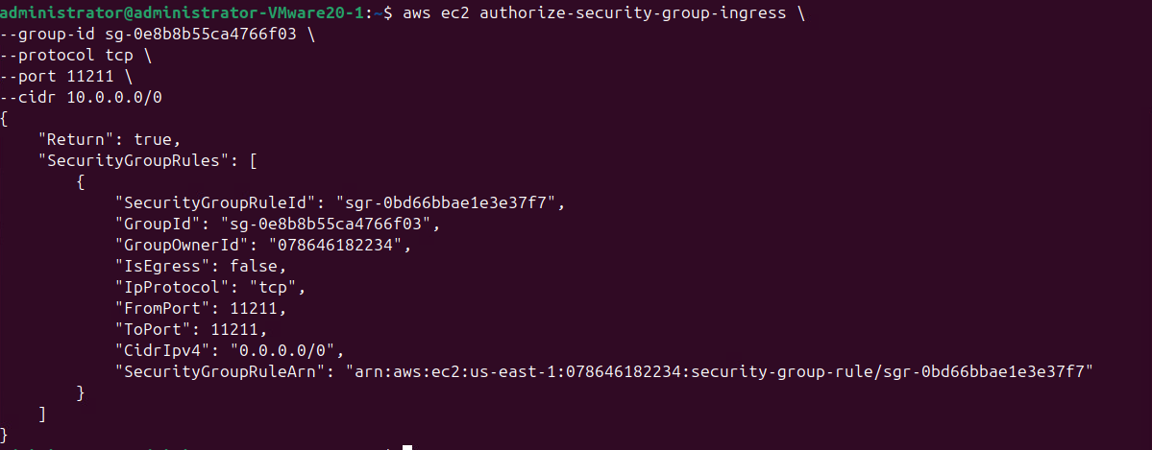
- Create an EC2 instance via the following command:

aws ec2 run-instances --image-id ami-013f17f36f8b1fefb --count 1 --instance-type t1.micro --key-name your_key_name --security-group-ids your_sec_grp_id --subnet-id your_subnet_id --associate-public-ip-address

aws ec2 run-instances \
--image-id ami-013f17f36f8b1fefb \
--count 1 \
--instance-type t3.micro \
--key-name usersam2-key \
--security-group-ids sg-0e8b8b55ca4766f03 \
--subnet-id subnet-048109d99999c8dae \
--associate-public-ip-address

What is the output?

{
"ReservationId": "r-0087d2c330753ffaa",
"OwnerId": "078646182234",
"Groups": [],
"Instances": [
{
"Architecture": "x86_64",
"BlockDeviceMappings": [],
"ClientToken": "25289eaf-e0ed-4d24-a307-c1ab1ccf10ed",
"EbsOptimized": false,
"EnaSupport": true,
"Hypervisor": "xen",
"NetworkInterfaces": [
{
"Attachment": {
"AttachTime": "2025-11-16T17:30:08+00:00",
"AttachmentId": "eni-attach-07fa16567c27b7bc3",
"DeleteOnTermination": true,
"DeviceIndex": 0,
"Status": "attaching",
"NetworkCardIndex": 0
},
"Description": "",
"Groups": [
{
"GroupId": "sg-0e8b8b55ca4766f03",
"GroupName": "usersam2"
}
],
"Ipv6Addresses": [],
"MacAddress": "12:a6:96:a8:dd:69",
"NetworkInterfaceId": "eni-0413d4b5ffd5c78fd",
"OwnerId": "078646182234",
"PrivateDnsName": "ip-10-0-10-67.ec2.internal",
"PrivateIpAddress": "10.0.10.67",
"PrivateIpAddresses": [
{
"Primary": true,
"PrivateDnsName": "ip-10-0-10-67.ec2.internal",
"PrivateIpAddress": "10.0.10.67"
}
],
"SourceDestCheck": true,
"Status": "in-use",
"SubnetId": "subnet-048109d99999c8dae",
"VpcId": "vpc-0202cda9d76509845",
"InterfaceType": "interface",
"Operator": {
"Managed": false
}
}
],
"RootDeviceName": "/dev/sda1",
"RootDeviceType": "ebs",
"SecurityGroups": [
{
"GroupId": "sg-0e8b8b55ca4766f03",
"GroupName": "usersam2"
}
],
"SourceDestCheck": true,
"StateReason": {
"Code": "pending",
"Message": "pending"
},
"VirtualizationType": "hvm",
"CpuOptions": {
"CoreCount": 1,
"ThreadsPerCore": 2
},
"CapacityReservationSpecification": {
"CapacityReservationPreference": "open"
},
"MetadataOptions": {
"State": "pending",
"HttpTokens": "optional",
"HttpPutResponseHopLimit": 1,
"HttpEndpoint": "enabled",
"HttpProtocolIpv6": "disabled",
"InstanceMetadataTags": "disabled"
},
"EnclaveOptions": {
"Enabled": false
},
"PrivateDnsNameOptions": {
"HostnameType": "ip-name",
"EnableResourceNameDnsARecord": false,
"EnableResourceNameDnsAAAARecord": false
},
"MaintenanceOptions": {
"AutoRecovery": "default",
"RebootMigration": "default"
},
"CurrentInstanceBootMode": "legacy-bios",
"Operator": {
"Managed": false
},
"InstanceId": "i-0191dcb77b4115617",
"ImageId": "ami-013f17f36f8b1fefb",
"State": {
"Code": 0,
"Name": "pending"
},
"PrivateDnsName": "ip-10-0-10-67.ec2.internal",
"PublicDnsName": "",
"StateTransitionReason": "",
"KeyName": "usersam2-key",
"AmiLaunchIndex": 0,
"ProductCodes": [],
"InstanceType": "t3.micro",
"LaunchTime": "2025-11-16T17:30:08+00:00",
"Placement": {
"AvailabilityZoneId": "use1-az2",
"GroupName": "",
"Tenancy": "default",
"AvailabilityZone": "us-east-1a"
},
"Monitoring": {
"State": "disabled"
},
"SubnetId": "subnet-048109d99999c8dae",
"VpcId": "vpc-0202cda9d76509845",
"PrivateIpAddress": "10.0.10.67"
}
]
}

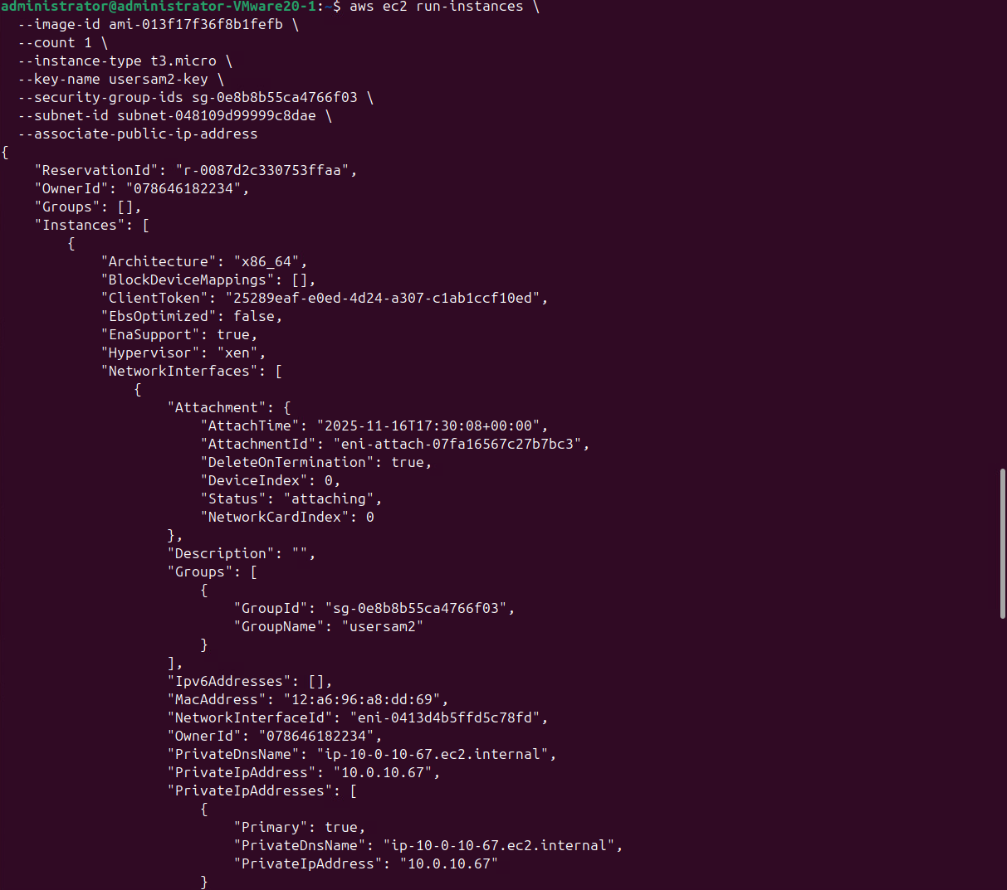
Part 2: Performance testing

- Please ssh into the instance you created in step 6. Switch to root and then install ruby via the following command:
ssh -i /home/administrator/usersam2.pem ubuntu@44.202.73.50

apt-get update
apt-get install ruby1.9.1

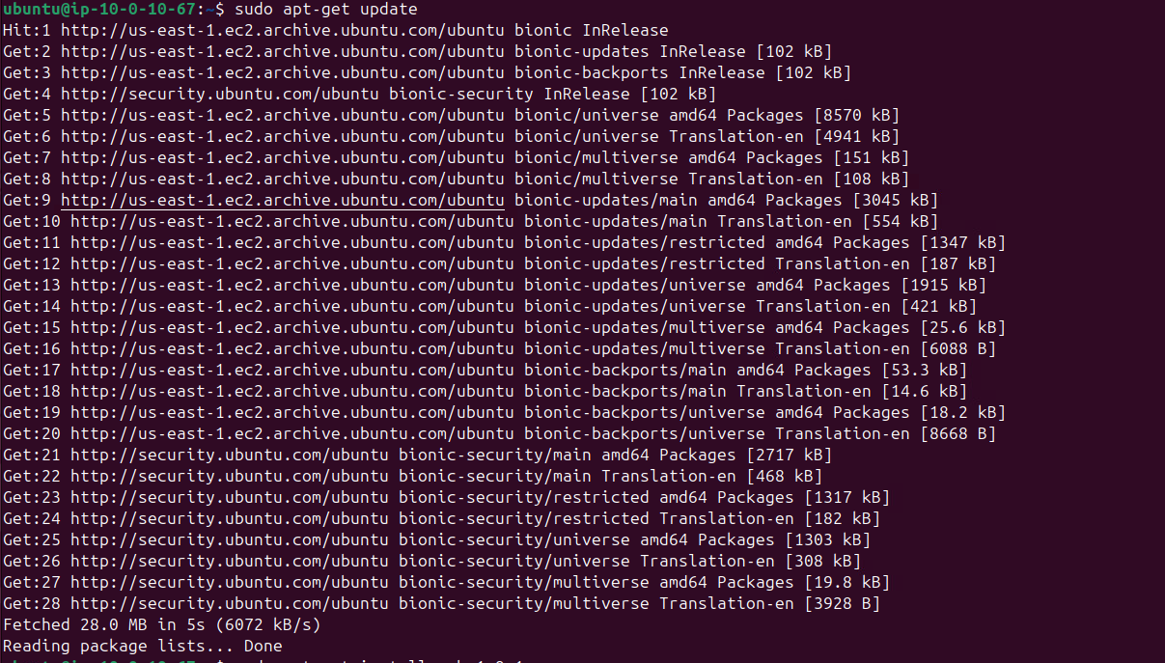
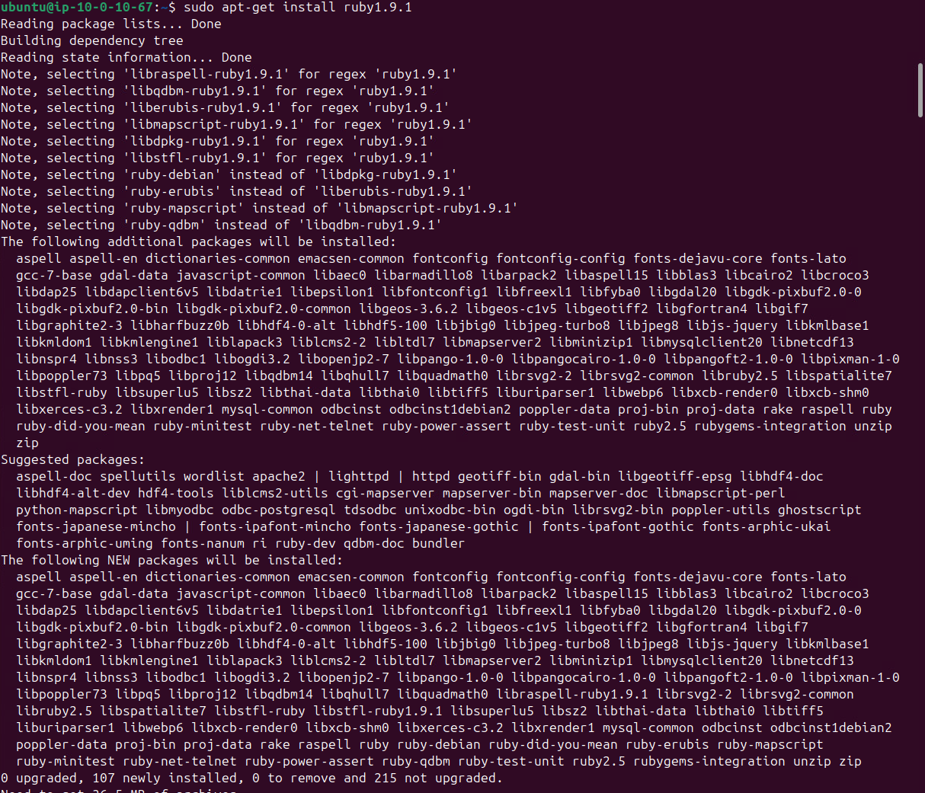
Note: if your ssh terminal is frozen at this step or below steps, you need to ssh into your instance again and continue.

- Create a small ruby script named fib.rb with the following content to measure how long it takes to compute the Fibonacci numbers without using Elasticache.

#!/usr/bin/ruby1.9.1

require 'benchmark'

def fib(n)
return n if n < 2
return fib(n-1) + fib(n-2)
end

max = ARGV[0].to_i
(1..max).each do |num|
bm=Benchmark.measure { fib(num) }
puts "#{num}: #{bm.utime}"
end
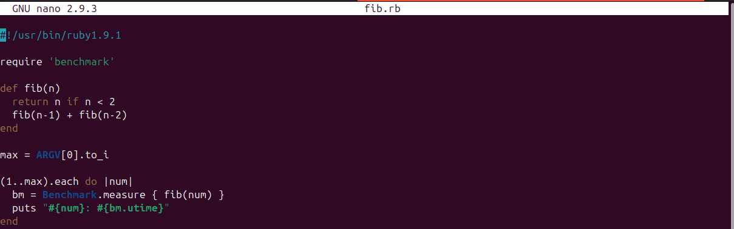
- Run fib.rb with the following commands:

chmod +x fib.rb

ruby fib.rb 40

Observe the number of seconds it takes to compute Fibonacci numbers. What is the output?

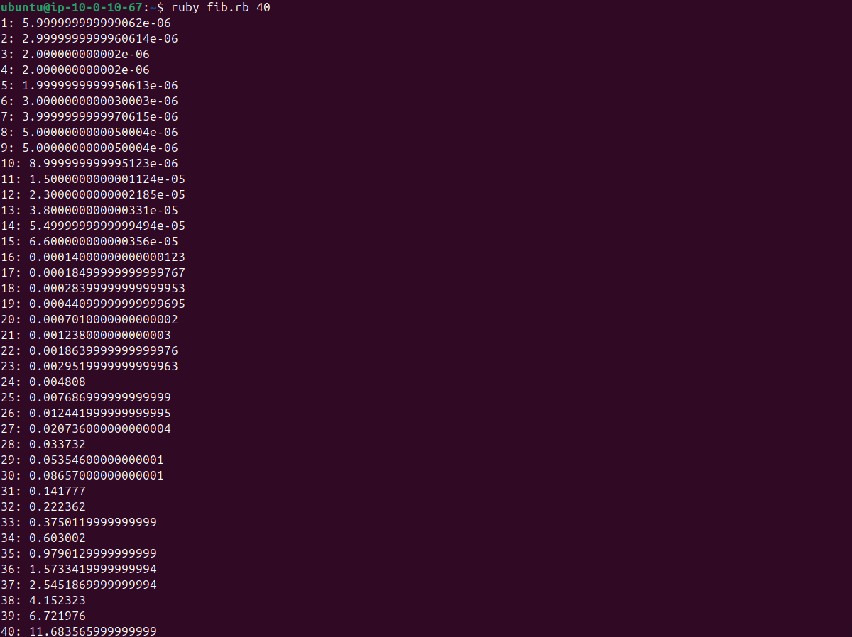

1: 5.999999999999062e-06
2: 2.9999999999960614e-06
3: 2.000000000002e-06
4: 2.000000000002e-06
5: 1.9999999999950613e-06
6: 3.0000000000030003e-06
7: 3.9999999999970615e-06
8: 5.0000000000050004e-06
9: 5.0000000000050004e-06
10: 8.999999999995123e-06
11: 1.5000000000001124e-05
12: 2.3000000000002185e-05
13: 3.800000000000331e-05
14: 5.4999999999999494e-05
15: 6.600000000000356e-05
16: 0.00014000000000000123
17: 0.00018499999999999767
18: 0.00028399999999999953
19: 0.00044099999999999695
20: 0.0007010000000000002
21: 0.001238000000000003
22: 0.0018639999999999976
23: 0.0029519999999999963
24: 0.004808
25: 0.007686999999999999
26: 0.012441999999999995
27: 0.020736000000000004
28: 0.033732
29: 0.05354600000000001
30: 0.08657000000000001
31: 0.141777
32: 0.222362
33: 0.3750119999999999
34: 0.603002
35: 0.9790129999999999
36: 1.5733419999999994
37: 2.5451869999999994
38: 4.152323
39: 6.721976
40: 11.683565999999999

- Please install the dalli gem which provides an interface to the elasticache via the following command:

gem install dalli gem install dalli -v 3.2.0
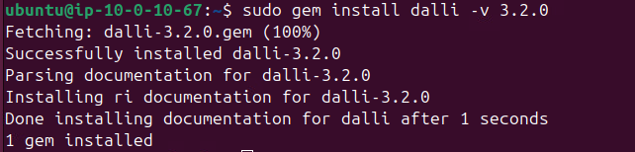
- Use the elasticache to improve the speed of the Fibonacci program. Please create a ruby script called fib-cache.rb with the following content:

#!/usr/bin/ruby1.9.1

require 'benchmark'
require 'dalli'

options = { :namespace => "app_v1", :compress => true }
$dc = Dalli::Client.new('your_elasticache_url_address:11211', options)

def fib(n)
key = "fib.#{n}"
fibc = $dc.get(key)
return fibc unless fibc.nil?
if (n < 2)
$dc.set(key, n)
return n
else
newfib = fib(n-1) + fib(n-2)
$dc.set(key, newfib)
return newfib
end
end

max = ARGV[0].to_i
(1..max).each do |num|
bm=Benchmark.measure { fib(num) }
puts "#{num}: #{bm.utime}"
end
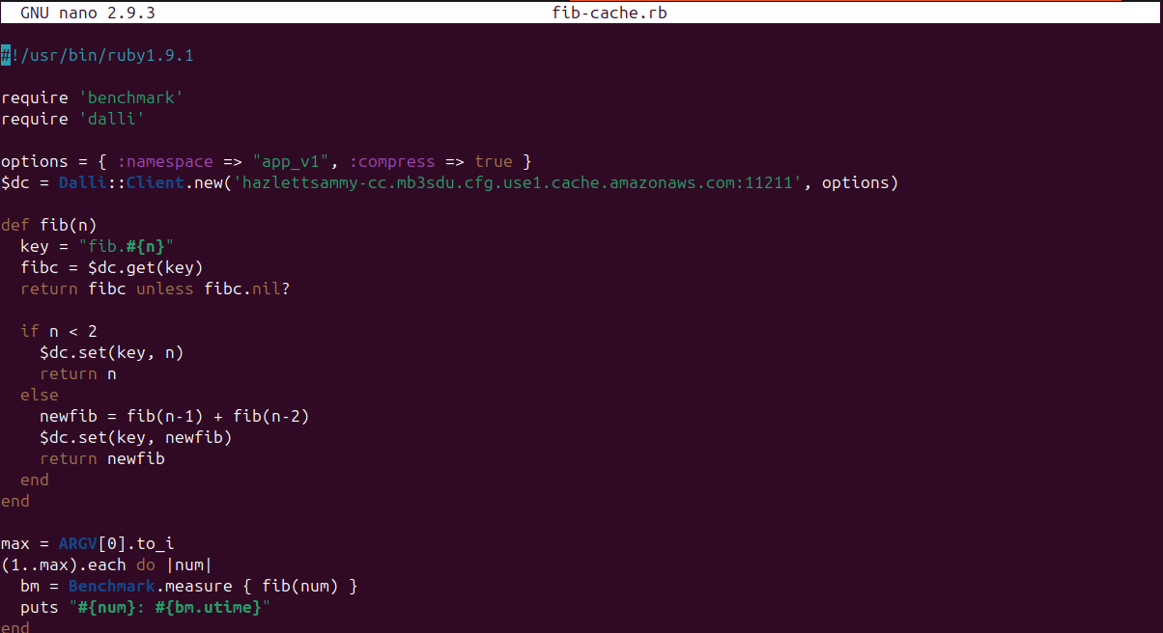

- Run fib-cache.rb with the following commands:

chmod +x fib-cache.rb
ruby fib-cache.rb 40

Observe the number of seconds it takes to compute Fibonacci numbers. What is the output? Please compare the output of fib-cache.rb with the output of fib.rb. Which script has better performance? Why?
fib.rb uses pure recursion and computes the same fibonacci values over and over again. While the fib.cache.rb stores each computed Fibonacci number in ElastiCache. Before computing, it checks if the result is already cached
1: 0.003038000000000013
2: 0.0006590000000000207
3: 0.00023700000000001498
4: 0.0002979999999999927
5: 0.0009829999999999839
6: 0.0006359999999999977
7: 0.0019619999999999915
8: 0.0015280000000000016
9: 0.0003969999999999807
10: 0.0
11: 0.0
12: 0.00027099999999999347
13: 0.0005519999999999969
14: 0.0005739999999999912
15: 0.0003029999999999977
16: 0.0011889999999999956
17: 0.00038599999999999746
18: 0.00041799999999997395
19: 0.00038399999999999546
20: 0.0003469999999999862
21: 0.00029400000000001647
22: 0.0
23: 0.0
24: 0.0
25: 0.0
26: 0.0
27: 0.0002859999999999807
28: 0.0009069999999999911
29: 0.0027550000000000074
30: 0.0017679999999999918
31: 0.0003820000000000212
32: 0.003269999999999995
33: 0.0011089999999999989
34: 0.00024299999999999322
35: 0.00026399999999998647
36: 0.00027099999999999347
37: 0.0004049999999999887
38: 0.0004720000000000002
39: 0.0005120000000000124
40: 0.0

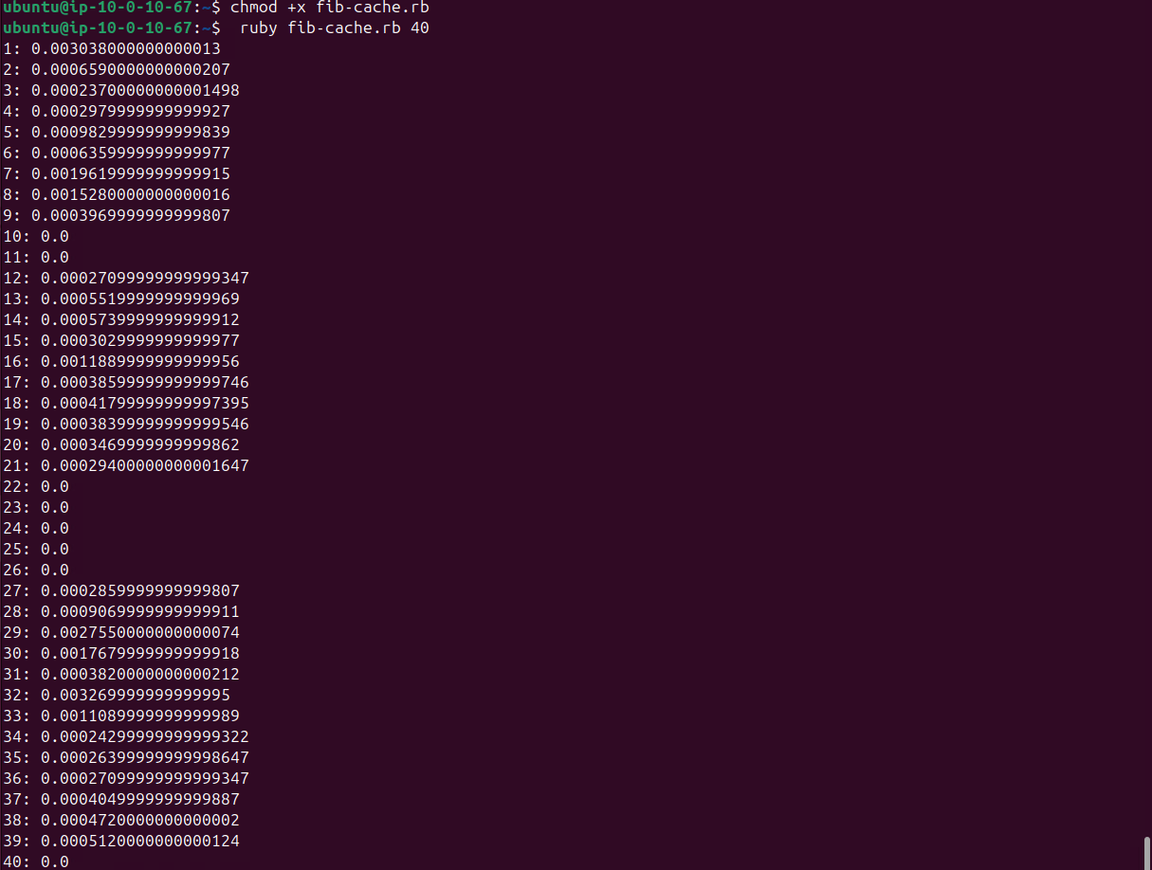

Part 3: Cleanup

- Please delete your cache cluster via the following:

aws elasticache delete-cache-cluster --cache-cluster-id your_UC_username-cc
aws elasticache delete-cache-cluster --cache-cluster-id hazlettsammy-cc

What is the output of the command?
{
"CacheCluster": {
"CacheClusterId": "hazlettsammy-cc",
"ConfigurationEndpoint": {
"Address": "hazlettsammy-cc.mb3sdu.cfg.use1.cache.amazonaws.com",
"Port": 11211
},
"ClientDownloadLandingPage": "https://console.aws.amazon.com/elasticache/home#client-download:",
"CacheNodeType": "cache.t3.micro",
"Engine": "memcached",
"EngineVersion": "1.6.22",
"CacheClusterStatus": "deleting",
"NumCacheNodes": 1,
"PreferredAvailabilityZone": "us-east-1a",
"CacheClusterCreateTime": "2025-11-16T17:28:33.415000+00:00",
"PreferredMaintenanceWindow": "sun:03:30-sun:04:30",
"PendingModifiedValues": {},
"CacheSecurityGroups": [],
"CacheParameterGroup": {
"CacheParameterGroupName": "default.memcached1.6",
"ParameterApplyStatus": "in-sync",
"CacheNodeIdsToReboot": []
},
"CacheSubnetGroupName": "mysubnetgroup",
"AutoMinorVersionUpgrade": true,
"SecurityGroups": [
{
"SecurityGroupId": "sg-0e8b8b55ca4766f03",
"Status": "active"
}
],
"TransitEncryptionEnabled": false,
"AtRestEncryptionEnabled": false,
"ARN": "arn:aws:elasticache:us-east-1:078646182234:cluster:hazlettsammy-cc",
"ReplicationGroupLogDeliveryEnabled": false,
"LogDeliveryConfigurations": [],
"NetworkType": "ipv4",
"IpDiscovery": "ipv4"
}
}

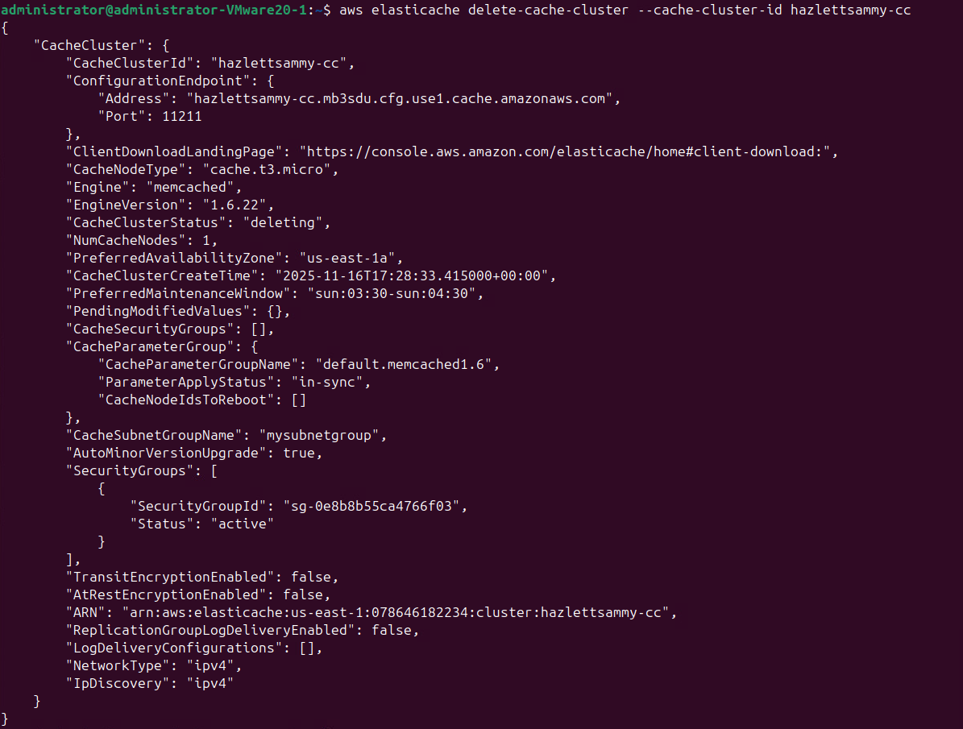
- Please delete your EC2 instance.

What command did you run?

aws ec2 terminate-instances --instance-ids i-0191dcb77b4115617 --region us-east-1

{
"TerminatingInstances": [
{
"InstanceId": "i-0191dcb77b4115617",
"CurrentState": {
"Code": 32,
"Name": "shutting-down"
},
"PreviousState": {
"Code": 16,
"Name": "running"
}
}
]
}

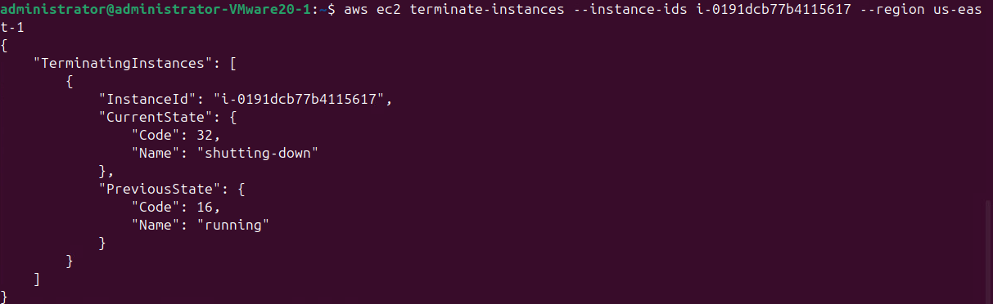
Submission instruction

After completing this work, submit this word document with your answers to the Canvas. In your word document, your answers should be in blue print.

